 **ANNA UNIVERSITY** 

**NAAN MUDHALVAN – GUIDED PROJECT**

**DOCUMENTATION**

**TRANSPARENT EDUCATION DATA MANAGEMENT**

|  |  |
| --- | --- |
| DATE | 31 OCTOBER 2023 |
| TEAM MEMBERS WITH NM ID | 1. DHARUN M -  0270CBCD3358D93874A40B917EEC65EC 2. DIVYA DHARSHINI –   087EE4C0342F965ADBA46 49B908C2642   1. ELASUKUMARAN E - 23556780714CDCFB5B84BF4E9269022A 2. GOWTHAM R –   0BF3F06AC53C10E89F446EF2C7C77B3C   1. VYSHNAVI M –   4284E4FD1316A93BEA54DC B745B8F87F |
| PROJECT NAME | TRANSPARENT EDUCATION DATA MANAGEMENT |
| COLLEGE NAME | ALAGAPPA COLLEGE OF TECHNOLOGY, ANNA UNIVERSITY |

**INTRODUCTION:**

**BLOCKCHAIN:**

Blockchain is like a digital ledger that records transactions across multiple computers in a secure and transparent way. It's the tech behind cryptocurrencies, but its applications go beyond that to areas like smart contracts and decentralized apps.

**1.1 Project Overview:**

Transparent Education Data Management is a comprehensive initiative aimed at improving the transparency and efficiency of educational data management systems. This project addresses the critical need for accessible, accurate, and secure data in the education sector, enabling educational institutions, policymakers, and stakeholders to make informed decisions and enhance the overall quality of education.

**1.2 Purpose:**

The project aims to increase transparency within the education sector by providing stakeholders with real-time access to accurate and up-to-date educational data. This transparency helps ensure that the data remains open and accessible to those who need it. Transparent Education Data Management. It seeks to minimize errors and discrepancies in educational data, leading to more reliable and trustworthy information for decision-making. It empowers educational institutions, policymakers, and other stakeholders to make informed, data-driven decisions to enhance the quality of education. Ultimately, the project’s purpose is to contribute to the improvement of educational outcomes by providing the tools and information necessary for institutions and policymakers to allocate resources effectively and make informed decisions.

**LITERATURE SURVEY:**

**2.1 Existing Problems:**

Educational data is often scattered across various departments and systems within educational institutions, making it challenging to access and consolidate for comprehensive analysis. Manual data entry and outdated systems lead to inaccuracies in educational data, which can result in incorrect decision-making and resource allocation. With an increasing amount of sensitive student and institutional data being stored digitally, concerns about data security, privacy, and compliance with data protection regulations are significant issues. Different departments within educational institutions often maintain their own isolated data systems, which makes it difficult to share data and gain a holistic view of educational performance. Many educational systems rely on outdated or batch-based reporting, resulting in delayed access to critical information needed for timely decision-making. Stakeholders, including students, parents, and policymakers, often lack access to detailed educational data, leading to transparency gaps and a lack of trust in the system.

**2.2 Reference:**

|  |  |  |
| --- | --- | --- |
| **S. No.** | **Literature** | **Author** |
| **1** | Transparency in Education: An International Study of Accountability in Higher Education | Stephen P. Heyneman and Kathryn F. Connolly. |
| **2** | Measuring What Matters in Education | Organization for Economic Co-operation and Development (OECD). |
| **3** | Data Management for Researchers: Organize, maintain and share your data for research success | Kristin Briney. |
| **4** | Data Analytics for Education | Ryan S.J.D. Baker and George Siemens. |

**2.3 Problem Statement Definition:**

The current state of education data management faces a multitude of challenges that impede the effective functioning of educational institutions and hinder data-driven decision-making. These challenges include data fragmentation, inaccuracy, security concerns, limited accessibility, data silos, lack of real-time data, integration issues, resource allocation inefficiencies, transparency gaps, regulatory compliance hurdles, data redundancy, and limited data analytics capabilities. The problem at hand is the need to develop and implement a comprehensive and innovative Transparent Education Data Management system that addresses these issues. This system should ensure the accessibility, accuracy, security, and transparency of educational data while promoting data-driven improvements in the education sector. The lack of such a system hampers educational institutions, educators, students, and policymakers in their efforts to make informed decisions, allocate resources efficiently, and build trust in the education system. The project aims to provide a solution to these pressing challenges and transform the management of educational data for the betterment of the entire education sector.

**IDEATION & PROPOSED SOLUTION:**

**3.1 Empathy Map Canvas:**

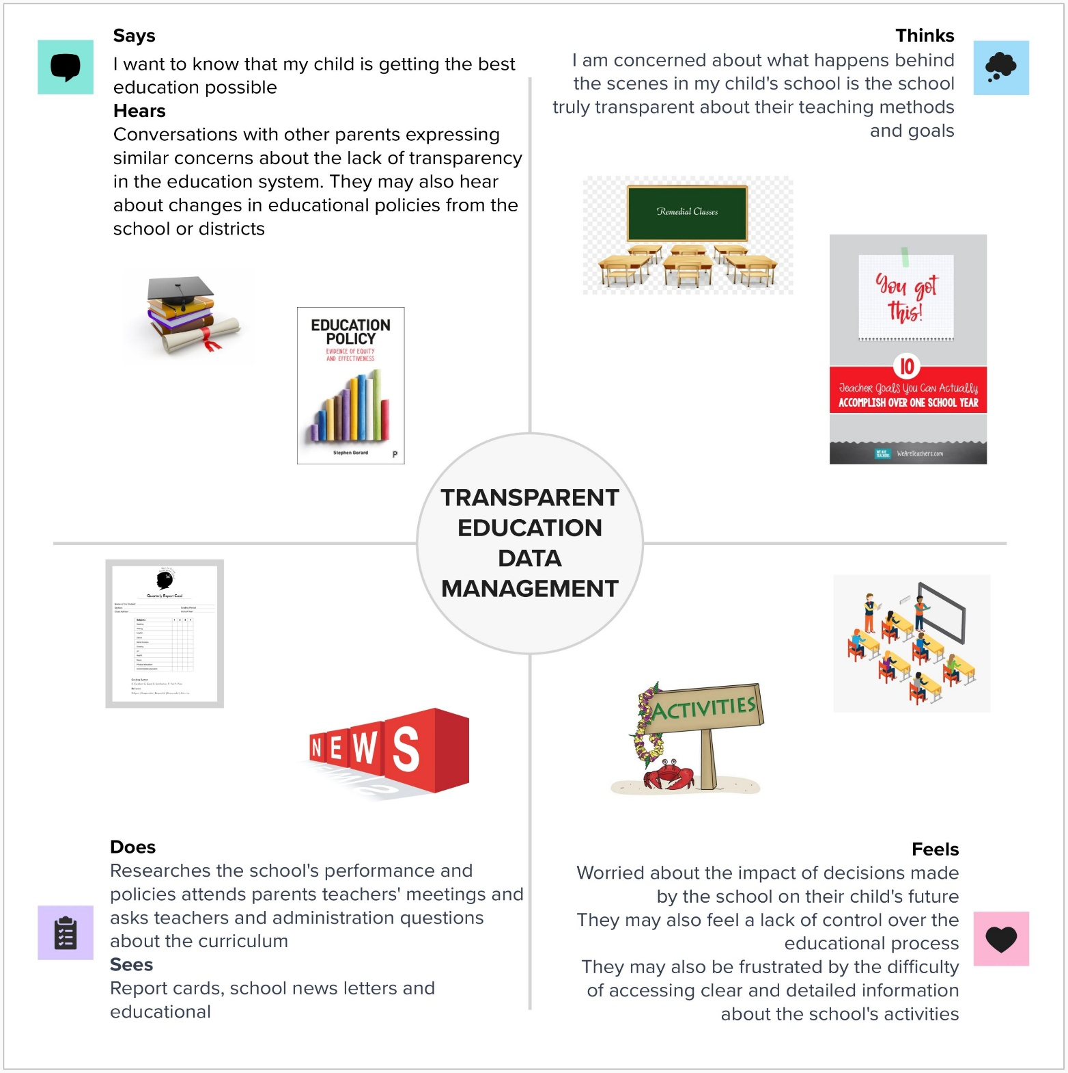

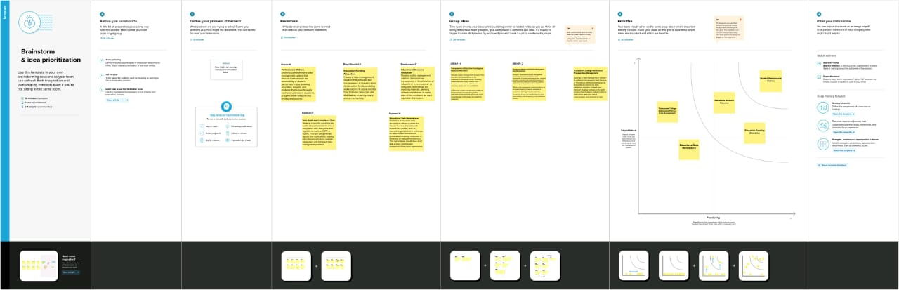**3.2 Ideation & Brainstorming:**

**REQUIREMENT ANALYSIS:**

**4.1 Functional requirements:**

The functional requirements of this project are Visual Studio Code, one remix id platform (node.js connector), file explorer, meta mask chrome extension and a source code file.

When designing a blockchain-based project for "Transparent Education Data Management," you need to define both functional and non-functional requirements to ensure that the system effectively meets its objectives. Here are requirements for such a project:

**Functional Requirements:**

1. **User Registration and Authentication:**

- Implement a user registration system for students, teachers, administrators, and other stakeholders.

- Enable secure user authentication using cryptographic techniques, such as public and private keys.

2. **Data Storage and Immutability**:

- Use blockchain technology to store educational data in a decentralized and immutable ledger.

- Ensure that once data is added to the blockchain, it cannot be altered, ensuring data integrity.

3. **Data Ingestion and Verification:**

- Develop a mechanism for ingesting data from educational institutions and verifying its authenticity.

- Implement data validation and verification processes to ensure the accuracy and integrity of the data.

4. **User Access Control:**

- Define access control mechanisms using smart contracts to specify who can access, modify, and view specific data.

- Ensure that roles and permissions are programmatically enforced.

5. **Data Retrieval and Transparency:**

- Enable users to retrieve and view educational data with appropriate permissions.

- Create a transparent system where stakeholders can trace data changes and access a complete audit trail.

6. **Reporting and Analytics:**

- Implement reporting and analytical tools to provide insights into student performance, attendance, and other educational metrics.

- Leverage smart contracts and data analysis to generate real-time and historical reports.

7. **Communication and Notifications:**

- Develop messaging and notification features to support communication among students, teachers, administrators, and parents.

8. **Security:**

- Use blockchain's inherent security features, such as cryptographic hashing and decentralized consensus, to protect data from unauthorized access or tampering.

9. **Integration with External Systems:**

- Create APIs or interfaces for integration with other educational systems and databases.

- Ensure data interoperability and seamless exchange of information.

10. **Data Privacy and Compliance:**

- Implement encryption and hashing techniques to safeguard sensitive data, adhering to relevant data protection regulations, such as GDPR or FERPA.

11. **Smart Contracts**:

- Develop and deploy smart contracts for executing specific actions, such as data validation, access control, and automated processes.

12. **Scalability and Performance:**

- Design the blockchain infrastructure to scale as the system grows, accommodating a potentially large volume of educational data.

Drive link of the source code: <https://drive.google.Com/file/d/15VKMwX8Ff-XgETI2v2tlkpNXS6Aw5Aeb/view?Usp=sharing>

**4.2 Non-Functional requirements:**

Non-functional requirements (NFRs) are essential for ensuring that the project like meets its performance, security, and usability goals.The project should have an intuitive and user-friendly interface to ensure ease of use. It should be highly available and reliable, with minimal downtime for maintenance or updates. It should be scalable to handle increased data and user loads over time. . Here are some non-functional requirements that could be relevant to the project:

**1. Performance:**

**- Response Time:** The system should provide quick response times for queries and data retrieval, ensuring that users can access information promptly.

**- Scalability:** The system should be able to handle increased loads as the user base and data volume grow.

**- Availability:** The system should be available 24/7, with minimal downtime for maintenance or updates**.**

**- Throughput**: The system should handle a certain number of concurrent users and transactions without performance degradation.

**2. Security:**

**- Data Encryption**: All sensitive data, including student and staff information, should be encrypted both in transit and at rest.

**- Authentication and Authorization:** The system should enforce robust user authentication and authorization mechanisms to ensure that only authorized personnel can access specific data.

**- Data Privacy:** Compliance with data protection regulations and standards, such as GDPR or HIPAA, should be ensured where applicable**.**

**- Audit Trails:** The system should maintain audit logs to track data access and changes for accountability and security purposes**.**

**3. Reliability:**

**- Fault Tolerance:** The system should continue to function in the presence of hardware or software failures without losing data or compromising the user experience.

**- Backup and Recovery:** Regular automated backups and a well-defined recovery process should be in place to mitigate data loss in case of unexpected events.

**4. Scalability:**

**- Horizontal Scalability:** The system should be designed to scale horizontally by adding more servers or resources to handle increased demand.

**- Vertical Scalability:** The system should also be able to scale vertically by utilizing more powerful hardware if required**.**

**5. Usability:**

**- User Interface (UI) Design:**The user interface should be intuitive and user-friendly, promoting ease of use for both technical and non-technical users**.**

**- Accessibility:**The system should comply with accessibility standards to ensure it can be used by individuals with disabilities**.**

**6. Interoperability:**

**- Integration:**The system should be able to integrate with other educational software, systems, or databases to exchange data efficiently**.**

**- Data Exchange Formats:** Support for standard data exchange formats (e.g., XML, JSON) should be provided for interoperability with external systems.

**7. Compliance:**

**- Regulatory Compliance:**Ensure that the system complies with relevant laws and regulations related to education data management, such as FERPA (Family Educational Rights and Privacy Act).

**8. Performance Testing:**

**- Load Testing:** Conduct load testing to ensure the system can handle the expected number of users and data volume**.**

**- Stress Testing:**Assess how the system performs under extreme conditions to identify potential bottlenecks or failures.

**9. Documentation:**

**- User Documentation:** Provide comprehensive user documentation and training materials to assist users in navigating and using the system effectively.

**- System Documentation**: Maintain detailed technical documentation for system administrators and support personnel**.**

**10. Monitoring and Reporting:**

**-** Implement monitoring tools and generate reports for system performance, usage patterns, and potential issues, enabling proactive management and decision-making.

**PROJECT DESIGN:**

**5.1 Data Flow Diagram & User Stories**

Characteristic of blockchain technologies:

Some key characteristics of blockchain technologies are listed as follows:

* **Increased capacity**: Blockchain technology can increase the capacity of an entire network. One such example is the supercomputer created by Stanford University usedfor medical research.
* **Better security:** Blockchain technology offers better security as it provides for a network of numerous computer nodes that can be used for networking transactions .
* **Immutability:** Blockchain uses immutable ledgers, and all databases require trust of a third party to keep them secure from hackers. Blockchain applications, such as Bitcoin, maintain the ledger in a never-ending state of forward momentum.
* **Faster settlement**: Blockchain technology relies on faster speeds and saves time for institutions and consumers. One example from banking is that blockchain makes money transfer fast and convenient.
* **Decentralized System:** Blockchain technology offers a decentralized system that stores the assets in a network and can be accessed via the internet. The asset may be a contract or document of importance. The manager of blockchain technology has control over the accounts of individuals and can transfer anything to anyone. This technology is proving to be an effective tool for decentralizing the web.
* **Minting:** Blockchain technology involves minting a problem in several ways. Proof of work is one approach guaranteeing an individual is engaged in a significant amount of computation work.

**5.1.1 Data Flow Diagram**

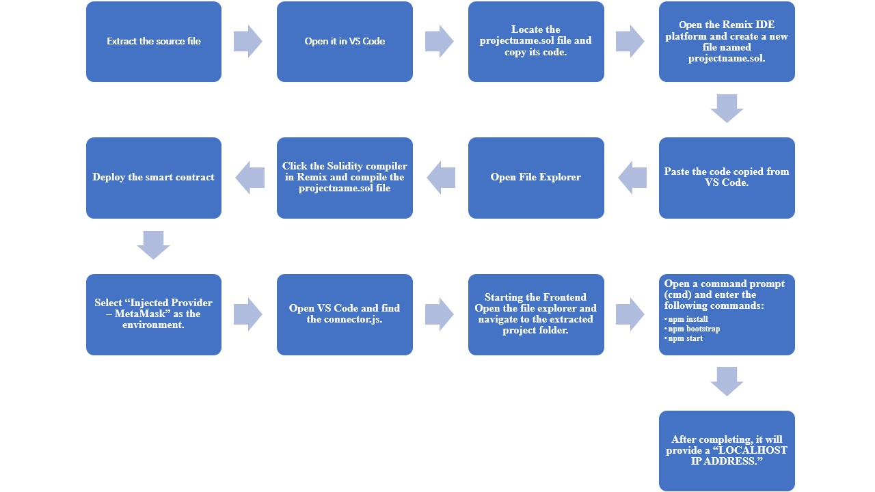

Source Data flow diagram

**5.1.2 User Stories:**

User stories are a useful way to outline the functional requirements of your project from the perspective of end-users and stakeholders.

* As an Administrator, I want user Account Management, create and manage user accounts, assign roles, and reset passwords as needed. Disable or delete user accounts when necessary.
* As an Educator, I want data entry and management, enter student grades, attendance records, and assessment results into the system. View and edit student information and performance data.
* As a Student, I want to access to Personal Data, view my own grades, attendance records, and assessment results. Access any relevant announcements or assignments from educators.
* As a Parent, I want to access to Child’s Data, view my child’s grades, attendance records, and assessment results. Receive notifications and updates on my child’s performance.

**5.2 Solution Architecture:**

The solution architecture for the project “**transparent education management**” is as follows:

1. **Presentation Layer:**

- **Web Interface:** Develop a web-based user interface for students, teachers, administrators, and other stakeholders to access and interact with the system. Ensure it's user-friendly and accessible.

2. **Application Layer:**

- User Management: Handle user registration, authentication, and authorization. Implement role-based access control to ensure data privacy.

- **Data Ingestion:** Accept data from various sources, including schools, colleges, and other educational institutions. Data can be in structured formats (e.g., databases) or unstructured (e.g., documents).

- **Data Processing:** Transform and validate incoming data, ensuring data quality and consistency.

- **Business Logic:** Implement the core logic of the system, including data retrieval, analysis, reporting, and automation of tasks related to education data management.

3. **Data Layer:**

- **Data Storage**: Choose an appropriate database system (e.g., relational database, NoSQL database) to store educational data. Ensure data encryption and adequate redundancy for data protection and availability.

- **Data Warehousing:** Create a data warehouse for historical and analytical data, enabling in-depth reporting and data analysis.

- **Data Integration:** Establish ETL (Extract, Transform, Load) processes to consolidate data from multiple sources into a unified data store.

- **Data Privacy:** Implement data masking and anonymization techniques for sensitive information to maintain privacy while enabling analytics.

**4. Integration Layer:**

- **APIs:** Develop APIs to facilitate integration with external systems, such as student information systems, learning management systems, and government databases.

- **Message Queues:** Use message queues for asynchronous communication between system components to enhance system responsiveness and fault tolerance.

5. **Analytics Layer:**

- Reporting and Dashboards: Create a reporting and dashboard system to provide real-time and historical data insights. Use visualization tools for clear data representation.

- **Data Analysis**: Implement data analytics and machine learning components for predictive analytics, performance assessments, and data-driven decision-making.

6. **Security Layer:**

- **Security Mechanisms**: Incorporate security measures, including encryption, firewalls, intrusion detection systems, and access controls to protect data from unauthorized access and cyber threats.

- **Compliance:** Ensure the system complies with relevant data protection regulations (e.g., FERPA) and standards (e.g., OWASP for web security).

7. **Infrastructure Layer:**

- **Cloud Hosting:** Consider cloud-based infrastructure to provide scalability and cost-effectiveness. Alternatively, you can opt for on-premises or hybrid infrastructure based on your organization's needs and constraints.

- **Load Balancing:** Implement load balancers to distribute traffic evenly and ensure high availability.

- **Redundancy:** Set up redundancy and failover mechanisms to minimize downtime.

8. **Monitoring and Management Layer:**

- **Logging and Monitoring:** Utilize monitoring tools to keep track of system performance, security, and anomalies. Implement log management for auditing and troubleshooting.

- **Alerting:** Configure alerting systems to notify administrators of critical events or performance issues.

9. **Backup and Disaster Recovery:**

- Develop a robust backup and disaster recovery plan to ensure data integrity and system availability in case of unexpected events.

10. **Compliance and Auditing:**

- Implement tools and processes to monitor and demonstrate compliance with relevant education data management regulations.

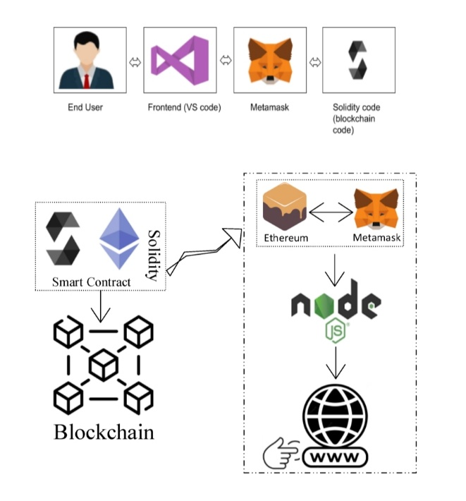

Schematic Diagram of Solution Architecture

**PROJECT PLANNING & SCHEDULING:**

**6.1 Technical Architecture:**

Develop a responsive web-based frontend using technologies like HTML, CSS, and JavaScript. Implement a user-friendly interface that allows administrators, educators, students, and parents to access the system through web browsers. Create a backend server using a framework like Node.js, Django, or Ruby on Rails. This server will handle user authentication, data processing, data integration, validation, and communication with the database. Implement a relational database or data warehouse to store and manage educational data. Use database management systems like PostgreSQL, MySQL, or Microsoft SQL Server. Ensure that the database schema supports data integration and is optimized for efficient data retrieval. Integrate data analytics and reporting tools, such as Tableau, Power BI, or custom-built solutions, into the architecture. These tools should allow users to create, customize, and schedule reports and visualizations based on the educational data stored in the database. Host the application and database on a secure and scalable cloud platform, such as AWS, Azure, or Google Cloud. Implement security measures, including encryption, role-based access control, and firewall configurations. Regularly update and maintain the infrastructure to ensure high availability and reliability.

**Project Overview:** The project aims to develop a secure and transparent blockchain-based voting system. It includes technical architecture design, sprint planning, estimation, and a sprint delivery schedule.

**Objective**: Design the technical architecture for the blockchain voting system.

**Tasks:**

Project Kickoff (Week 1):

* Define project scope, objectives, and key stakeholders.
* Assemble project team.

Requirements Analysis(Week 2-3):

* Gather functional and non-functional requirements.
* Define the scope of blockchain integration.

Technical Design(Week 4-5):

* Create a high-level system architecture.
* Select the blockchain platform (e.g.,Ethereum, Hyperledger) and consensus mechanism.
* Design data models and smart contracts.
* Define security protocols and privacy measures.

System Prototyping(Week 6-8):

* Develop a prototype to validate the technical design.
* Conduct initial security and performance tests.

Technical Architecture Review(Week 9):

* Review the technical architecture with stakeholders.

Address feedback and finalize the design

**6.2 Sprint Planning & Estimation:**

Before each sprint, conduct backlog refinement to review and prioritize user stories. Work with stakeholders to identify and prioritize the most critical features and improvements based on their importance and impact. Ensure that the sprint goal is specific and measurable, making it easier to track progress. Use a relative estimation technique, such as story points or ideal days, to estimate the effort required for each user story. Involve the development team in the estimation process to gain a consensus on the effort require in a sprint planning meeting, select a set of user stories from the prioritized backlog that can be realistically completed in the upcoming sprint. Break down user stories into tasks and define acceptance criteria for each. Used velocity to determine the number of story points or tasks that can be taken into the sprint based on the sprint duration.

**6.3 Sprint Delivery Schedule:**

**Sprint 1 (Duration: 1 week)**

Sprint Goal:

Set up the foundational architecture for the system.

User Stories:

User authentication and role-based access control.

Database schema design for central data repository.

Basic user interface for administrators.

User Story Estimations:

12 story points.

Deliverables:

Authentication system, basic database structure, and administrator login functionality.

**Sprint 2 (Duration: 1 week)**

Sprint Goal:

Implement data integration and validation processes.

User Stories:

Data integration from one data source (e.g., student records).

Data validation and error handling.

User Story Estimations:

10 story points.

Deliverables:

Data integration module for one data source, validation framework.

**Sprint 3 (Duration: 1 week)**

Sprint Goal:

Enhance data management and analytics.

User Stories:

Complete data integration for additional data sources (e.g., attendance, assessments).

Implement basic reporting and visualization features.

User Story Estimations:

15 story points.

Deliverables:

Data integration for additional sources, basic reporting tools.

**Sprint 4 (Duration: 1 week)**

Sprint Goal:

Improve data security and user management.

User Stories:

Implement data encryption and access controls.

User account management features (create, reset password, etc.).

User Story Estimations:

14 story points.

Deliverables:

Enhanced data security and user management capabilities.

**Sprint 5 (Duration: 1 week)**

Sprint Goal:

Enhance the user interface and user experience.

User Stories:

Improve the user interface for educators, students, and parents.

Implement user notifications and communication features.

User Story Estimations:

10 story points.

Deliverables:

Improved user interfaces and communication features.

**CODING AND SOLUTIONING:**

**Feature:**

Transparent education data management

**Description:**

In the context of education data management, this feature allows administrators, staff members, students and as well as parents

**Code:**

// SPDX-License-Identifier: MIT

pragma solidity ^0.8.0;

contract collegeCertificate {

address public owner;

struct Certificate {

string studentName;

string courseName;

uint256 DateOfGraduation;

uint256 issueDate;

address issuer;

}

uint256 public totalCertificates;

mapping(uint256 => Certificate) public certificates;

event CertificateIssued(

uint256 indexed certificateId,

string studentName,

string courseName,

uint256 issueDate,

address indexed issuer

);

constructor() {

owner = msg.sender;

}

modifier onlyOwner() {

require(msg.sender == owner, "Only contract owner can call this");

_;

}

function issueCertificate(

string memory studentName,

string memory courseName,

uint256 _dateOfGraduation,

uint256 issueDate

) external onlyOwner {

uint256 certificateId = totalCertificates + 1;

certificates[certificateId] = Certificate({

studentName: studentName,

courseName: courseName,

DateOfGraduation : _dateOfGraduation,

issueDate: issueDate,

issuer: msg.sender

});

totalCertificates = certificateId;

emit CertificateIssued(

certificateId,

studentName,

courseName,

issueDate,

msg.sender

);

}

function getCertificate(

uint256 certificateId

) external view returns (string memory, string memory, uint256, uint256, address) {

Certificate memory cert = certificates[certificateId];

return (cert.studentName, cert.courseName, cert.DateOfGraduation, cert.issueDate, cert.issuer);

}

}

**PERFOMANCE TESTING:**

**8.1 Performance Testing:**

|  |  |  |  |
| --- | --- | --- | --- |
| **S.No.** | **Parameter** | **Values** | **Screenshot** |
| 1. | Information gathering | Setup all the Prerequisite: | Meta Mask Installed |
| VS Code Installed |
| Node js Installed |
| 2. | Extract the zip files | Open to VS code |  |
| 3. | Remix IDE  Platform exploring | Deploy the smart contract code    Deploy and run the transaction. By selecting the environment - inject the MetaMask. |  |
| 4 | Open file explorer | Open the extracted file and click on the folder  Open src, and search for utiles.  Open cmd enter command   1. npm install 2. npm bootstrap 3. npm start |  |
| 5 | LOCAL HOST IP ADDRESS | Copy the address and open it to chrome so you can see the front end of your project. |  |

**RESULT:**

**9.1 Output Screenshot**

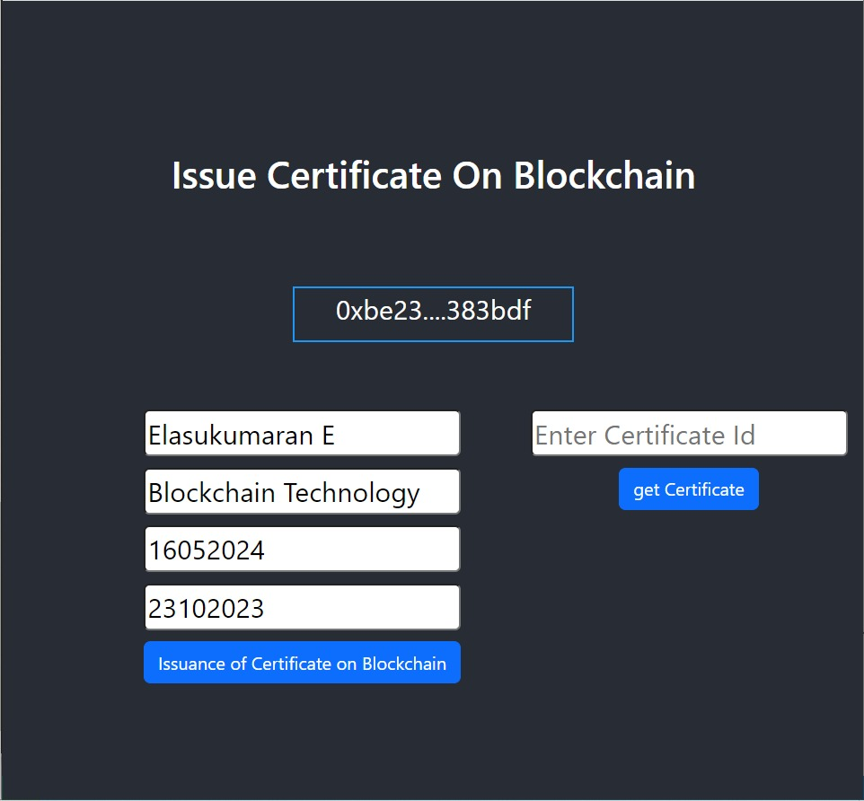

**ADVANTAGES AND DISADVANTGES:**

**10.1 Advantages:**

* The project enables educational institutions to make data-driven decisions, leading to better resource allocation and improved educational outcomes.
* The system enhances transparency and accountability, building trust between educational institutions, educators, students, and parents.
* It streamlines data management, reducing data redundancy and improving data accuracy through automation and validation.
* Users can create customized reports and visualizations, gaining valuable insights into student performance and educational trends.
* The project incorporates robust data security measures, ensuring compliance with data protection regulations and safeguarding sensitive information.

**10.2 Disadvantages:**

* Implementing the system can be complex and time-consuming, requiring significant resources and expertise.
* Managing sensitive student data raises privacy concerns that need to be addressed effectively to prevent data breaches.
* The project may involve significant initial costs for software development, hardware, and infrastructure.
* Training users and administrators to effectively utilize the system may take time and resources.
* Ongoing maintenance and regular updates are necessary to keep the system secure and operational, potentially incurring additional costs.

**CONCLUSION:**

The Transparent Education Data Management project represents a significant step toward modernizing and enhancing the educational sector. By addressing the challenges of data fragmentation, inaccuracy, security concerns, and limited accessibility, the project strives to empower educational institutions, educators, students, and parents with a robust system for data-driven decision-making.

The advantages of this project, such as data-driven decision-making, transparency, efficient data management, customized reporting, and data security, underscore its potential to improve the quality of education and foster greater trust and accountability within the system.

However, it is important to acknowledge the potential disadvantages, including implementation challenges, data privacy concerns, initial costs, user training requirements, and ongoing maintenance needs. These challenges highlight the need for careful planning, security measures, and the allocation of appropriate resources to ensure the project's success.

In conclusion, the Transparent Education Data Management project has the potential to revolutionize education data management, providing a platform that fosters transparency, efficiency, and informed decision-making. Its successful implementation and operation will depend on the dedication, expertise, and resources invested in addressing both the advantages and disadvantages, ultimately contributing to the advancement of education and the well-being of students and educational institutions.

**FUTURE SCOPE:**

* The future scope of the Transparent Education Data Management project is promising, with numerous opportunities for growth and enhancement.
* Integrating the system with popular Learning Management Systems (e.g., Moodle, Canvas, Blackboard) can provide a seamless experience for educators and students, allowing for a comprehensive view of educational data.
* Develop a mobile application to make educational data accessible on mobile devices, allowing students and parents to track progress and receive notifications on the go.
* Enhance communication features for educators, students, and parents, enabling real-time feedback, alerts, and collaboration.  
  Utilize artificial intelligence (AI) to provide deeper insights into educational data, such as identifying trends, suggesting improvements, and optimizing resource allocation.
* Explore blockchain technology to enhance data security, ensuring data immutability and traceability while maintaining privacy.

**APPENDIX:**

**SOURCE CODE:**

The source code of the project is given in the below drive link.

Source code link: <https://drive.google.Com/file/d/15VKMwX8Ff-XgETI2v2tlkpNXS6Aw5Aeb/view?Usp=sharing>

**GITHUB LINK:**

<https://github.com/blockchain-nm/Transparent-Education-Data-Management/tree/main>

**DEMONSTRATION VIDEO LINK:**

<https://drive.google.com/drive/folders/1y_V_SAstNPfZgB1zGvAr9qPeg-d-b6uw>